**Health and Social Care innovation Wales**

**National Innovation Pathway**

**___________________________________________________________________________**

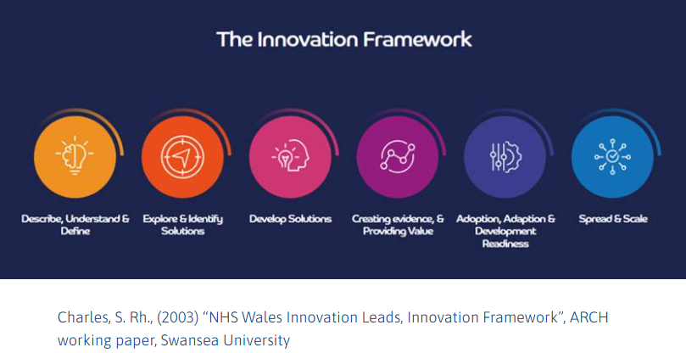

**Origin**

The Innovation Framework was developed as part of the Innovation Strategy for Wales and is based on the real-world experiences of innovation teams in Wales over the past 10 years.  It draws inspiration from existing approaches and frameworks, such as supply chain modelling, technology readiness levels and design thinking. This is not a flow or a linear process: innovation can come in at any stage of the Innovation Framework.

The Innovation Framework offers flexibility, guidance, and key reminders to help individuals, teams, and health boards navigate the tools and resources at their disposal. Each section outlines actionable steps, along with available resources and assets to support each stage of the process.

**Purpose**

The NHS in Wales Innovation Framework is designed to support health and care organisations across Wales by providing guidance to inform, influence, streamline and organise their innovation efforts. It provides a structured approach to fostering, managing, and scaling innovation. It serves as a guide for systematically identifying new opportunities, generating ideas, developing new products, services, or processes, and implementing them effectively. Health and Social Care organisations should use the Innovation Framework as a guide to developing and deploying their own local innovation pathways.

**What does it do?**

* Describes the sector, understanding who in the ecosystem can help you.
* Maps our resources, skills, and physical spaces.
* Avoids duplication.
* Identifies gaps where there is support and where we need align resources.
* Aids collaboration with industry, universities, and third sector.
* Deploys our assets to speed up innovation.
* Guides and stimulates innovation in health boards.
* Provides a common framework to build innovation processes, governance, and plans.
* Helps to develop and maintain University Health Board status.

The Innovation Framework collates activities into an order, thus providing guidance about how the NHS might approach their clinical and non-clinical innovation activities.

In addition, the Innovation Framework is a tool for engaging with industry, providing a clear message to businesses that Wales is the place to bring their clinical and non-clinical innovations. The Innovation Framework will encourage the consideration of adoption and future deployment strategies at an earlier stage of project development, to ensure that the data required to inform adoption is available when needed.

The pathway has 6 stages:

1. **Describe, Understand & Define**
2. Describe the activity (e.g. what actually happens, what services provided), resources (who does what, where do they do it, what facilities and equipment do they use, and how much does it cost) and performance (what is measured and what level of performance is achieved).
3. Gain a deep understanding of what the challenges might be.
4. Set out aspirations, objectives and opportunities.  What do I want to achieve?
5. **Explore and identify solution(s)**
6. Horizon scan – Looking around to understand what opportunities or solutions already exists
7. Demand signal – sharing to identify who can help develop opportunities and solve challenges
8. Develop ideas, plans and actions
9. **Develop solution(s)**
10. Develop promising solutions, such as new processes, practices, methods, models, roles, approaches, rules, strategies through active research
11. Create & develop prototypes (devices, digital). This may involve preclinical and/or clinical studies and research to satisfy the regulatory processes for an ‘approved’ technology
12. Make ready the solution for ‘creating evidence and proving value’ in real world conditions.
13. **Creating Evidence and Proving Value**
14. To test and evaluate the product/device/innovation activity.
15. Create the evidence to make a judgement based on criteria and evidence whether this creates value, quality and improves the outcome for staff and/or patients.
16. Establish whether the innovation works in a real-world environment.
17. **Adoption, Adaption & Deployment Readiness**
18. Making the innovation better from exposure to new contexts and teams
19. Re-testing and adapting the process innovation and/or technology innovation.
20. Helping the adopter – learn, introduce and manage change.
21. Preparing the innovation for spread/scale, e.g. agreeing strategy, refining business cases, engaging stakeholders, planning, developing training
22. **Spread and Scale** 
    * + 1. Making an innovation more widely known and adopted, such as raising awareness, building will and transferring skill to others.
        2. Increasing the impact and reach of an innovation.
        3. Dealing with the challenges of full-scale deployment and adoption